1. Who developed Python Programming Language?

Guido van Rossum developed Python Programming Language

1. Which type of programming does Python support?
   1. Imperative
   2. Procedural
   3. Functional
   4. Object Oriented

* Imperative Programming
  + - Focuses on HOW
    - Explicitly tells the computer how to accomplish a task
    - Following the "how-to-solve" approach, it makes direct changes to the state of the program; hence it is also called the stateful programming model.
    - Code

characters=['L','a','l','i','t','h','a']

string =''

for char in characters:

string=string+char

print (string)

* Procedural Programming
* Like Imperative programming - detailed steps are provided to computer - loops, control flow statements
* Statements are structured into procedures
* Modularized
* Code

def string(characters):

string=''

for char in characters:

string=string+char

return string

string(['L','a','l','i','t','h','a'])

* Functional Programming
  + Focuses on WHAT
  + Uses built-in higher-order functions - pure stateless functions. A higher-order function takes other function as an argument or returns them as a result.
  + Reduces lines of code
  + Uses pure stateless functions like lambda, map, filter, generators, decorators, recursions
  + Useful in recursion and concurrent execution
  + Code

import functools

characters=['L','a','l','i','t','h','a']

string=functools.reduce(lambda s,c:s+c,characters)

* Object Oriented Programming
  + Makes Code - Organized, Reusable and Easy to maintain
  + Object is basic entity created from class. Class is the blueprint of the object
  + Objects contain data and methods to modify the data
  + Code

class stringOps():

string=''

def __init__(self,characters):

self.characters=characters

def strinconcat(self):

for char in self.characters:

stringOps.string=stringOps.string+char

1. Is Python case sensitive when dealing with identifiers?

Yes, Python is case sensitive.

1. What is the correct extension of the python file?

.py

1. Is Python code compiled or interpreted?

Python is an interpreted, high-level, general-purpose programming language.

1. Name a few blocks of code used to define in python language

Indentation

1. Which Character is Used in Python to Make a Single Line Comment?

#

1. Mention function to find the version of python

import sys

print(sys.version)

1. Python supports the creation of anonymous functions (i.e. functions that are not bound to a name) at runtime, using a construct called **lambda.**
2. What does pip stand for?

Preferred Installer Program

1. Mention few built in functions in Python
   1. type()
   2. int()
   3. ord()
   4. sum()
   5. abs()
2. What is the maximum possible length of an identifier in python?

An identifier can have a maximum length of 79 characters in Python.

1. What are the benefits of Python?

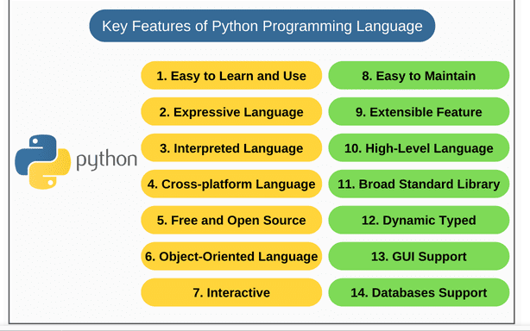

1. How is memory managed in Python?

Please refer to the mind map

1. How to install Python on Windows and set the PATH Variable?

* Install python from this link https://www.python.org/downloads/
* After this, install it on your PC. Look for the location where PYTHON has been installed on your PC using the following command on your command prompt: cmd python.
* Then go to advanced system settings and add new variable and name it as PYTHON_NAME and paste the copied path.
* Then look for the path variable, select its value and select edit
* Add a semicolon towards the end of the value if it's not present and then type %PYTHON_HOME%

1. Is indentation required in Python?

Yes